Comands for the terminal to start our django web server:

After install django (pip install django==(Version number))

The first command create a folder with all the .py files to get the app organized
The second command start the server

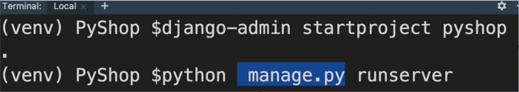
Create a new module in our project:
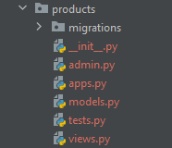
admin.py: How the administration panel of the app has to look like
apps.py: To store the configurations settings for the app
models.py: Where we define classes and new types for modeling the concepts in this app. (Ex: Products may have- product, category, review,..)

tests.py: Where the automatized tests should be written
views.py: What the user see when the user navigate to a certain page.

Starting our ecommerce logic:

Set the URL to a view:

1.) Create the functions (views) products/views.py file:
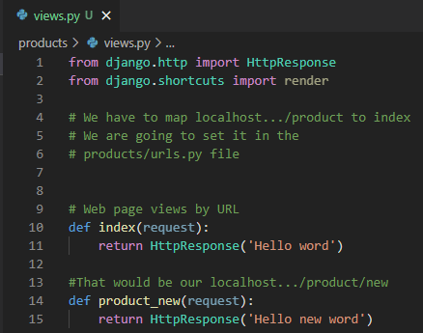

2.) We crate a .py file called urls.py and map each ‘URL’ to a view function:

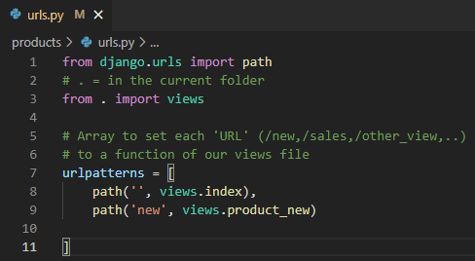

3.) We map the, in this case, products/ path to the products.urls that we created before that way Django is going to know where find what it has to show. In autogenerated ecomerce/urls.py file:
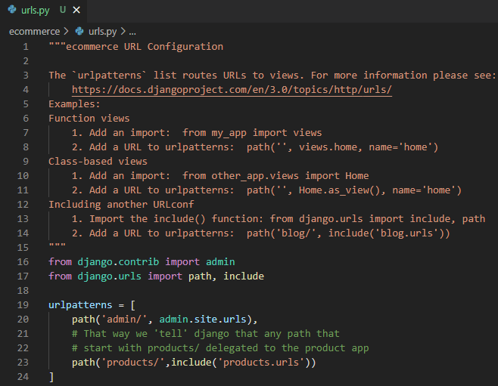
Creating some representations of a real world concept (models):

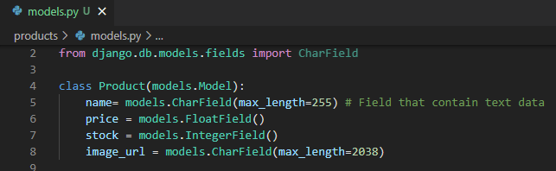

Create a data base for the storing products using our model:

This step is using sqlite which is fine for learning and smalls app.
We have to download https://sqlitebrowser.org/ to be able to visualize our data base.
We just have to drop our db.sqlite3 file in the DB Browser sqlite app.

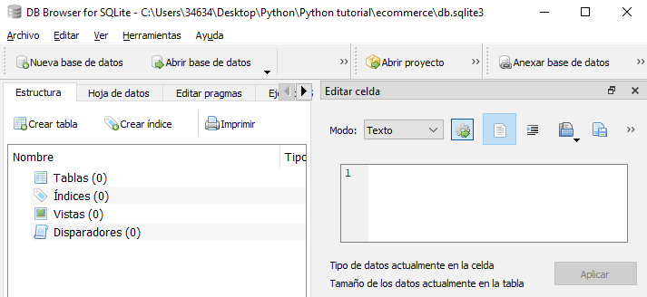

Now how to make Django created our model:

First we have to tell django about our app and in order to get that:

We have a list called INSTALLED_APPS in the ecommerce.settings.py file where we could see all the apps installed by default and we have a class called ProductsConfif where we store the configuration of our app so we have to get in the list the path of out class like so:

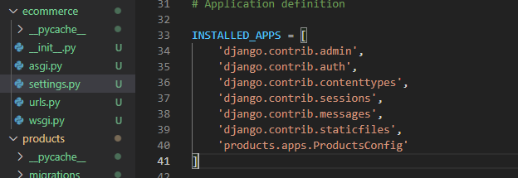
And now we can, trough the terminal, order to django that we want to create a table using our model the commands are, python manage.py makemigrations to create a file with a class in it which is in charge of some a operation to create out table, as we can see:

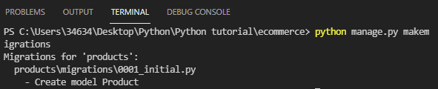
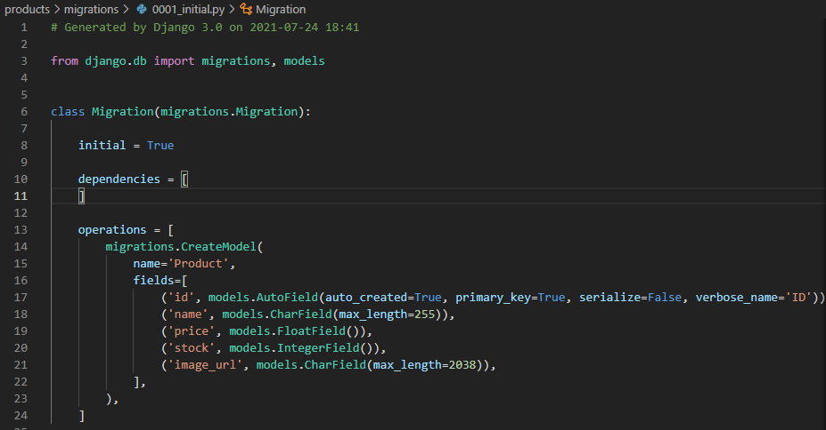
The id field is created automatically by Django.
And now to create the table we use the command python manage.py migrate:



Now if we drop the data base again in the DB browser for sqlite we see:

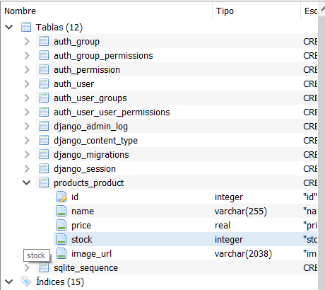
Work with the administration panel generated by Django:

If we type http://localhost:(your Django port)/admin we are going to see a logging panel generated for Django:
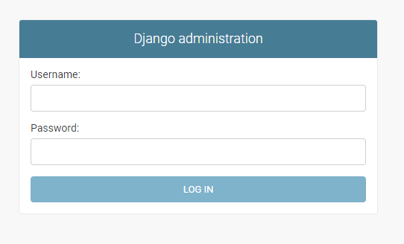

To sign in we have to created a super user using the terminal, like so:

command: python manage.py createsuperuser

and follow the instructions as we see in the picture below:

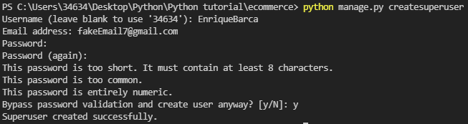
Now we can log in and see the Django superuser default panel, as we see below:

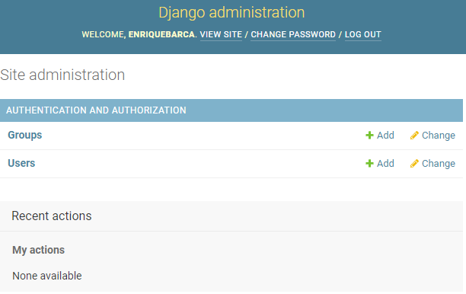

Now we are going to modify the panel to add our products to be able to administrate them from the panel.
We have to open the admin.py file and code the next lines:
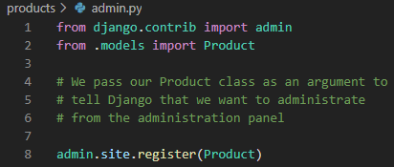

And if we go back to the web we are going to see how we have the new element to administrate from there:
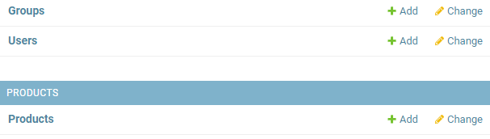
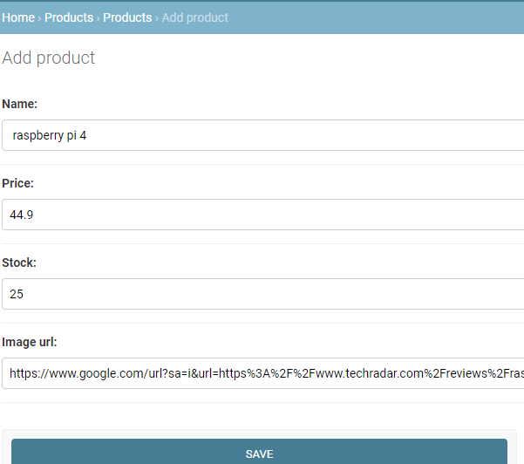
Customizing the admin panel.

As we see in the image below Django shows as not in a very clear way what product we have but we can change:

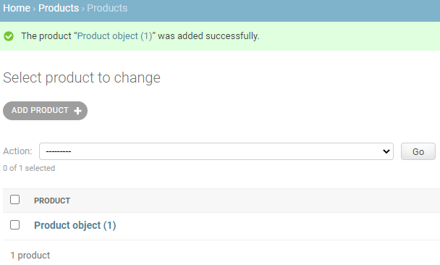

In the same file that we modify before admin.py we can create a way to see ours products, like so:

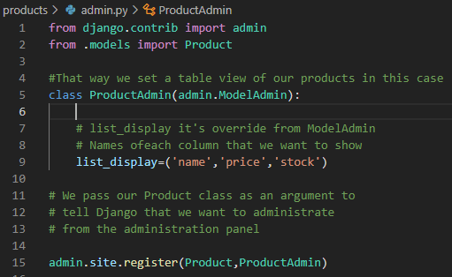
And now our management display looks like so:

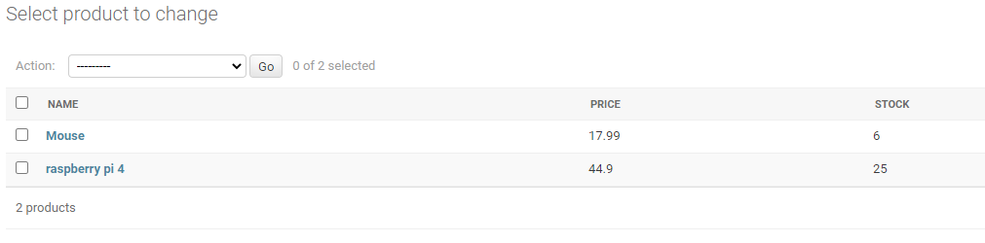

Show our data base registers in our ecommerce web.

1.) In our views.py we have to set in the functions the data of our data base.:

1.a) Import the products class, from .models import Products.
1.b) Using the methods we ask for the data that we want to show.
Ex: in the view function we can use:
Product.objects.all() → To show all the elements in the DB
Product.objects.filter() → to look for a certain product
Product.objects.get() → for a single product
Product.objects.save() → to add or update one

In this case we are going to use the all() method.

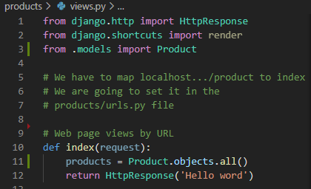

2.) We have to create a html template:

2.a) Create a folder inside our products folder called templates, it’s important use that name because is where Django is going to look at .
2.b) Create the template for the products.index, inside the template folder we have to create a file called index.html.
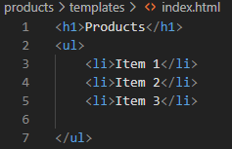

3.) We set the created index.html file to show it to the client.

3.a) In our index function we have to use the render obj and pass it 3 parameters,
request, which is the object that the function has as default as parameter, the template that we just created and a dictionary with the list of products that we took from the data base to show it in the template (Second argument). We have to something like:
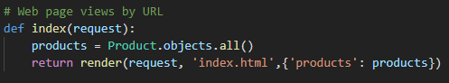
3.b) We have to replace the Item tags with our products using a template tag → {% %}
we use them to pass dynamic code, we would end with the template like so:

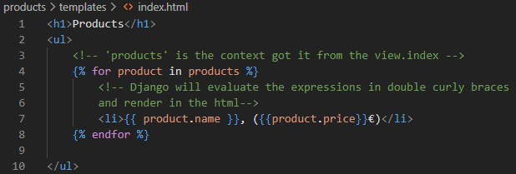

Which have the next result:

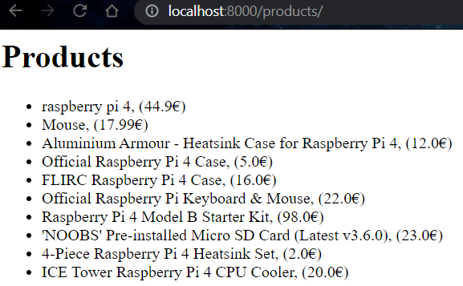
Get better look at our web using bootstrap framework.

1.) We have to get the basic template in https://getbootstrap.com/docs/5.0/getting-started/introduction/ and going down to “Starter template” , copy the html code and pasted in a new file inside the templates folder of our project.

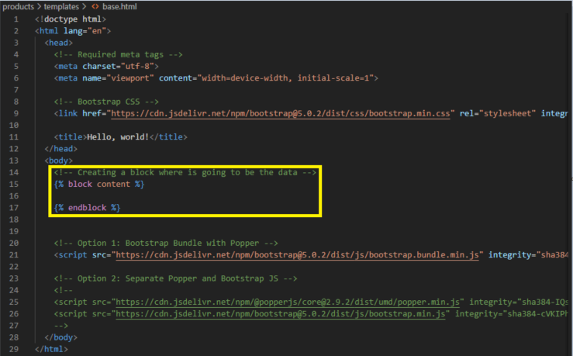
2.) We create a block content where is going to be our DB data, which we are going to get it from the index.html created before.
3.) We have to create the communication between our block gap and the information that content the index.html file, like so:
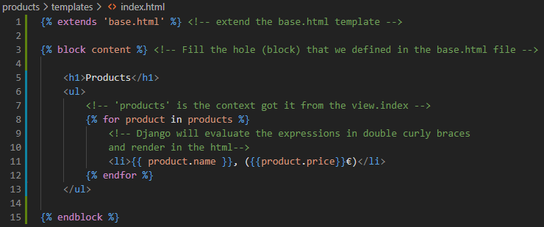
4.) now we have the data let’s add some style components to make the web look better.
We have to go to https://getbootstrap.com/docs/5.0/components/card/ and copy the code that is in the example section. We have to create a <div class="row"> and inside a <div class="col"> and inside them the code that we copy before. We should have something as it show below:
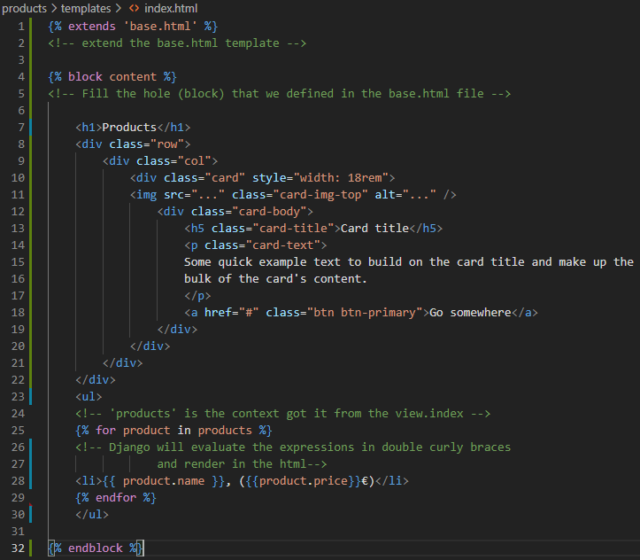

5.) Now we have to use the for loop already created and put it below our row div, that way we are going to render a column for each product. And in the different sections of the code paste we have to set the different values of our “Product”, we can delete the <ul> block created before.
The result should be something like so.
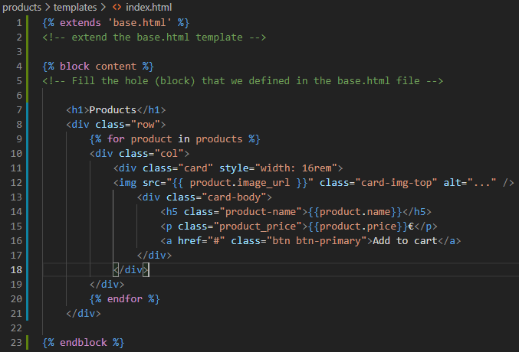

And we should end with a result like shown below:
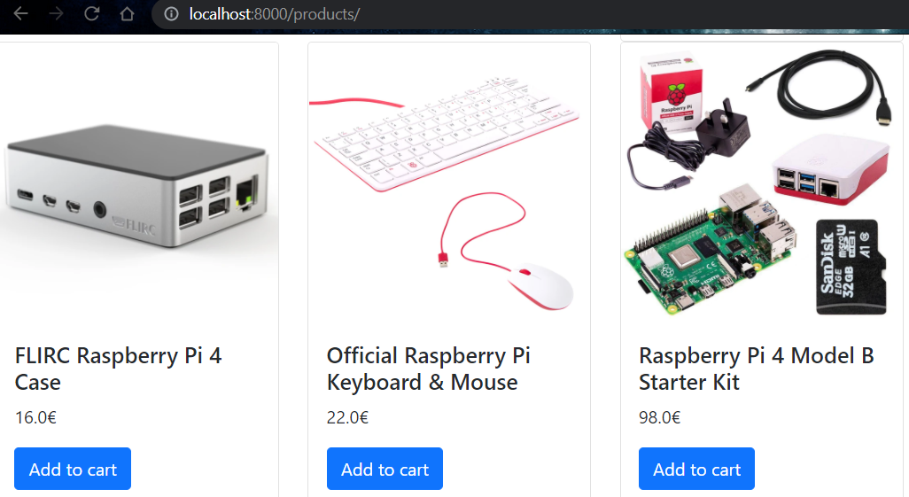
Creating a problem to learn how to fix it.

We create before the folder template inside the products folder but our base.html file is going to be use in most of the web window so we have to take it out to be accessible from others folders so we have to create a template folder and put it somewhere central, like so:

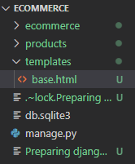

Now in our web, we are going to see the next error:

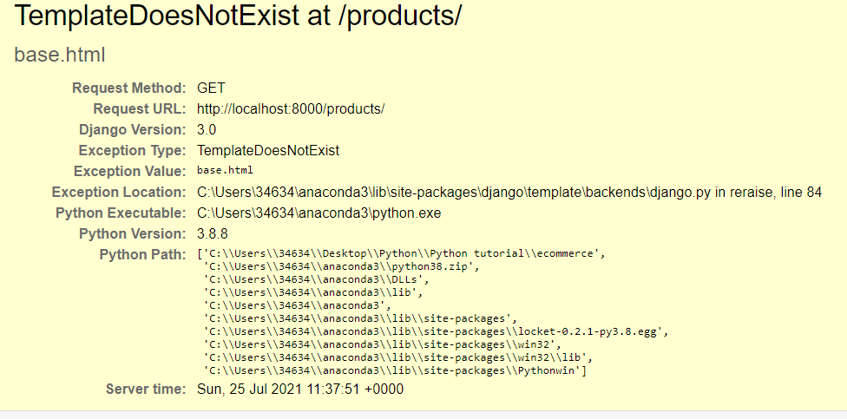

To fix it we have to tell Django that it have to see the new template folder in addition to install the app. In the setting.py file we have a BASE_DIR is set to the complete path where is storage this project so we have to add the template folder to it.

We have to look for TEMPLATES in setting.py and in the DIRS key we have to reference to the template folder like so:
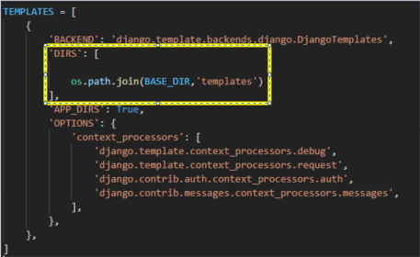
Now we should see our web as before.

Improving the look and feel of the web page.

Add a nav bar component.

1.) We have to go to https://getbootstrap.com/docs/5.0/components/navbar/ scroll down to brand and copy the code for this nav bar.

2.) We have to paste it in our base template because this template is gong to be in all our web windows. So we just have to paste it below the body tag, like so.
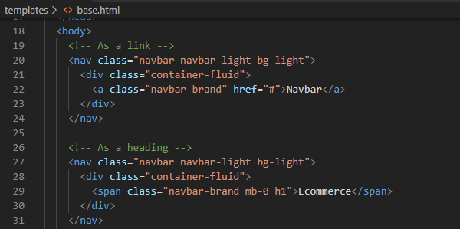

Add some padding with the help of bootstrap tags:

We are going to use the class container which has some padding by default, so the code would end looking like so:

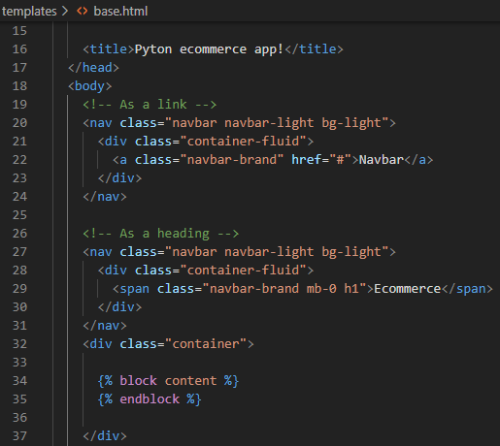

And our app like so:

